## Execution Demo

Now press F5 to launch the application and navigate to Employee controller by appending /Employeein the URL.

You can see the page as shown below.

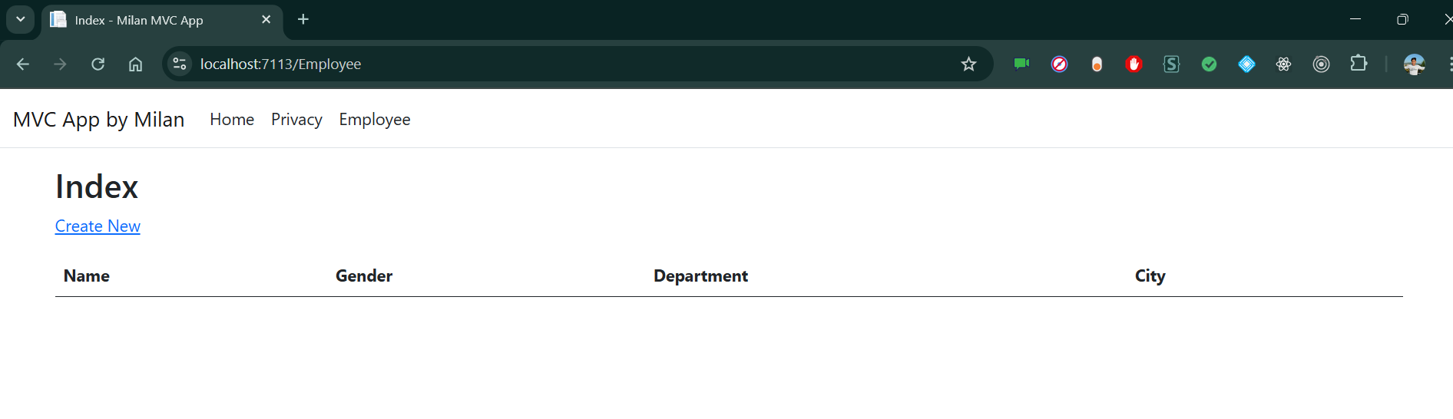

Click on CreateNew to navigate to Create view. Add a new Employee record as shown in the image below.

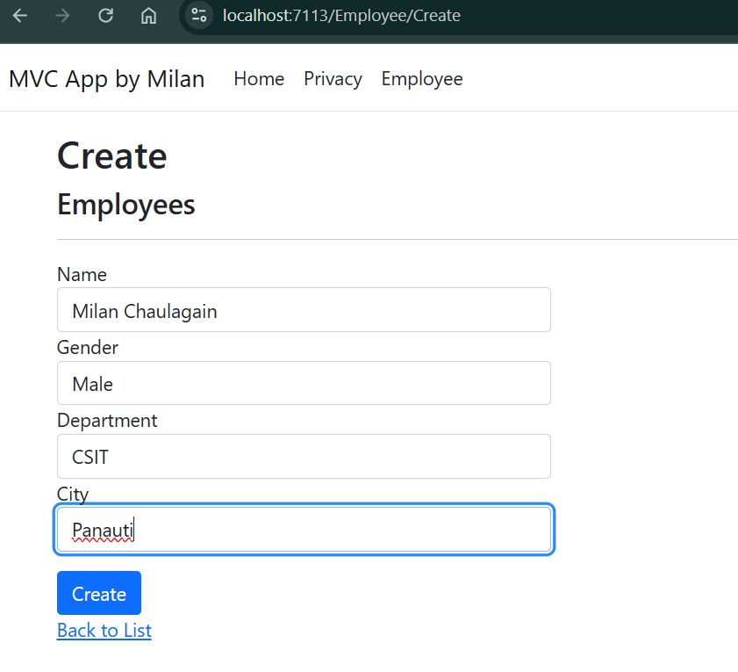

After inserting the data in all the fields, click on “Create” button. The new employee record will be created and you will be redirected to the Index view, displaying records of all the employees. Here, we can also see action methods Edit, Details, and Delete.

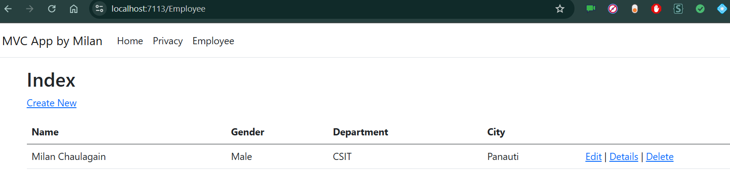

Similarly, Adding some more records.

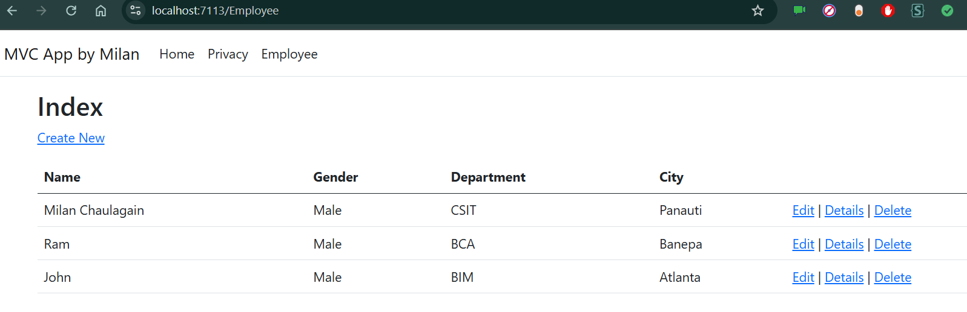

If we want to edit an existing employee record, then click Edit action link. It will open Edit View as below where we can change the employee data.

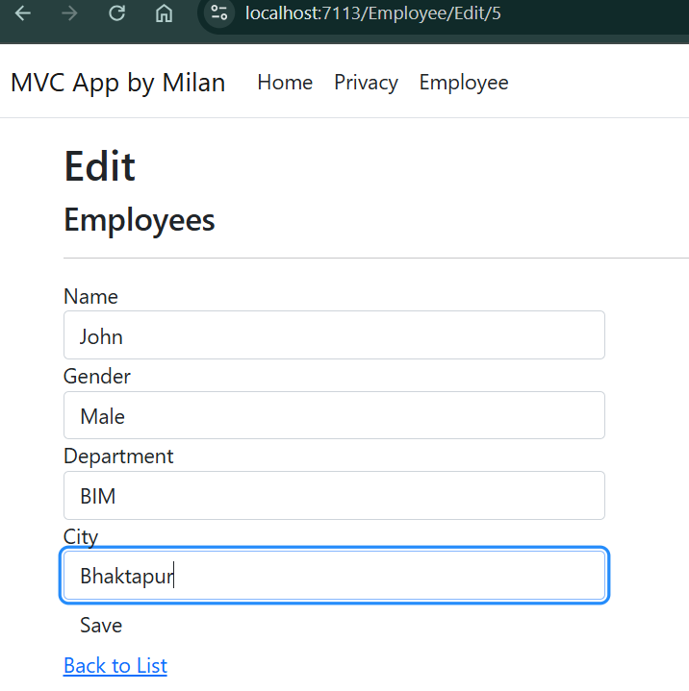

Here we have changed the City of employee John from Atlanta to Bhaktapur. Click on “Save” to return to the Index view to see the updated changes as highlighted in the image below.

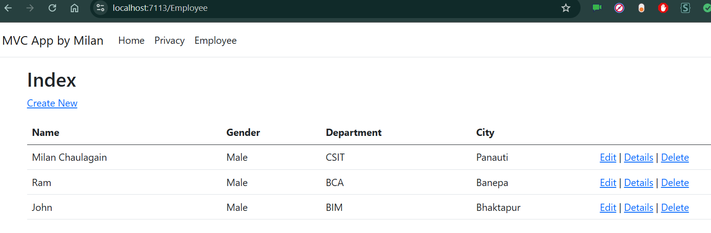

If we miss any fields while editing employee records, then Edit view will also throw required field validation error message

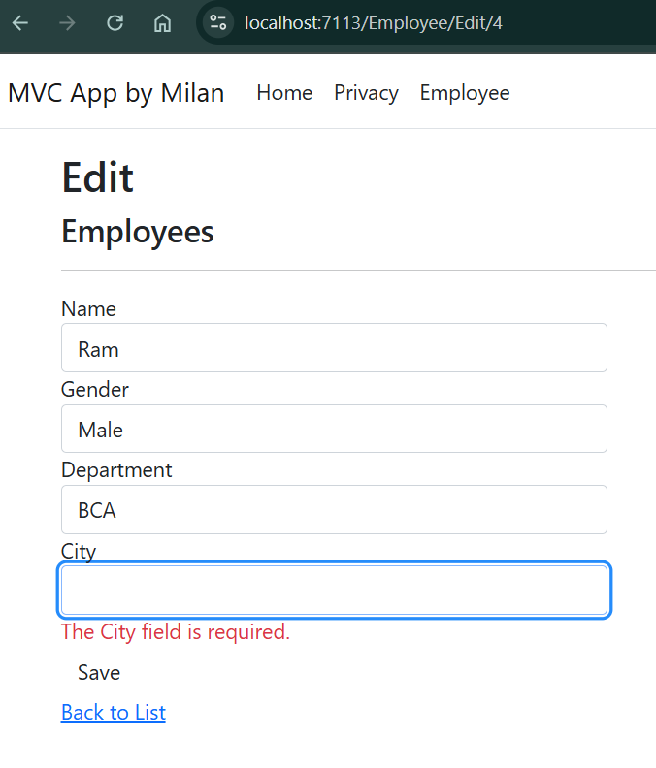

If you want to see the details of any Employee, then click on Details action link, which will open the Details view, as shown in the image below.

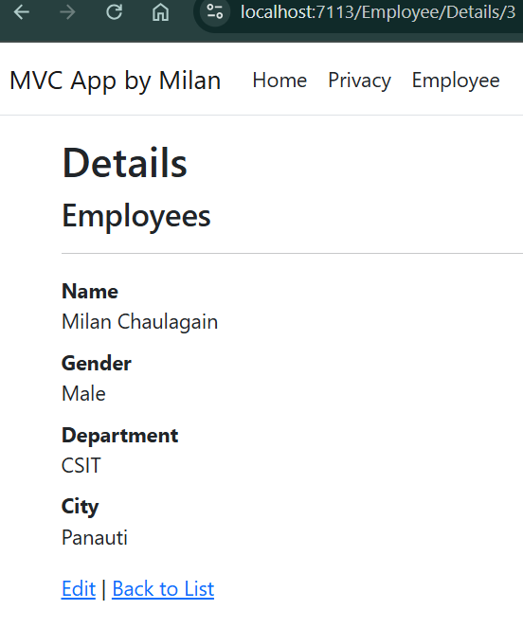

Click on “Back to List” to go back to Index view. Now, we will perform Delete operation on an employee named Venkat. Click on Delete action link which will open Delete view asking for a confirmation to delete.

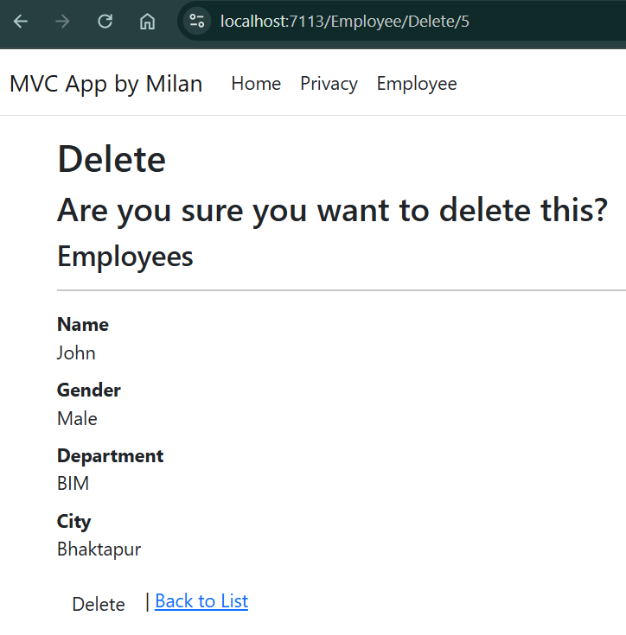

Once we click on Delete button, it will send HttpPost request to delete employee record and we will be redirected to the Index view. Here, we can see that the employee with name Venkat has been removed from our record.

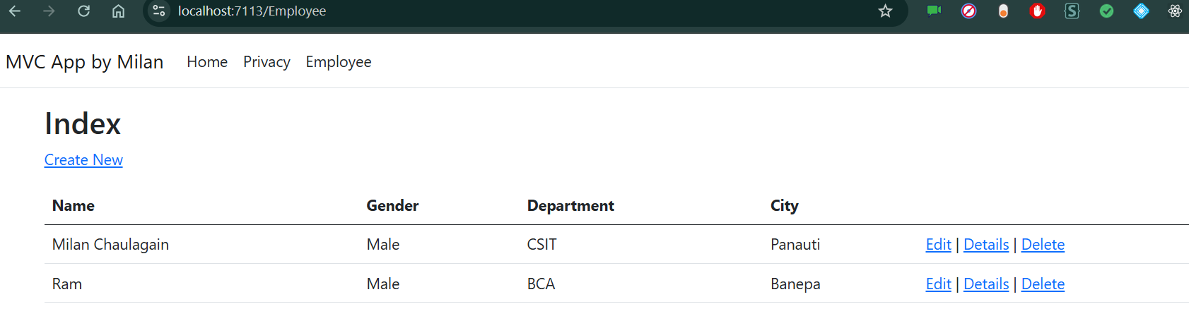

## Conclusion

We have learned about creating a sample MVC web application with ASP.Net Core using ADO.NET and SQL server. In this web application we have included the CRUD operation where user can create, display, edit and delete the Employee records.